Theme Development

02 Theme dev

Place holder Screenshot

Tony Evans

See next page for screenshots of what your page should look like

In this folder you can see the following:

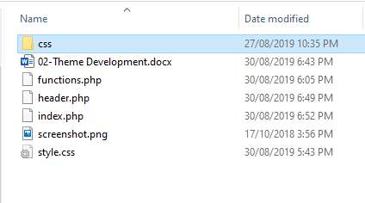

The files in this folder are similar but his time includes a CSS folder and a “header.php” file. The CSS file is still the same with on the commented information in.

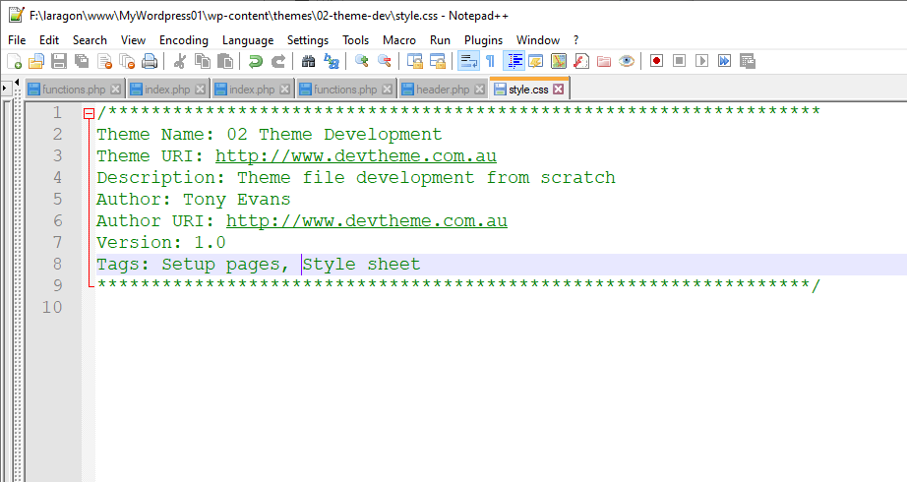

Open the “index.php” to see what has been included. It should look like the screen shot below.

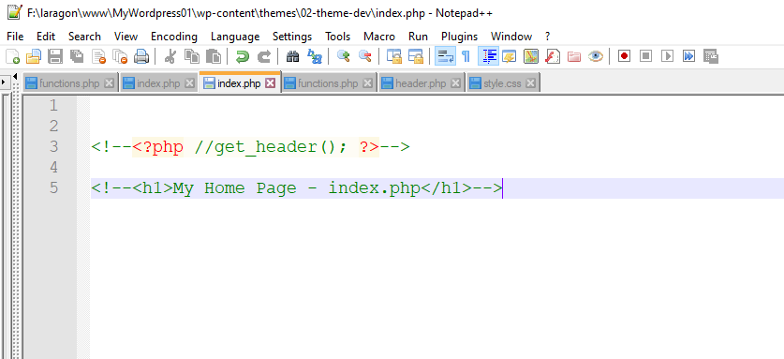

When this theme has been activated you should be seeing the same as “01-Theme Development”, a blank screen.

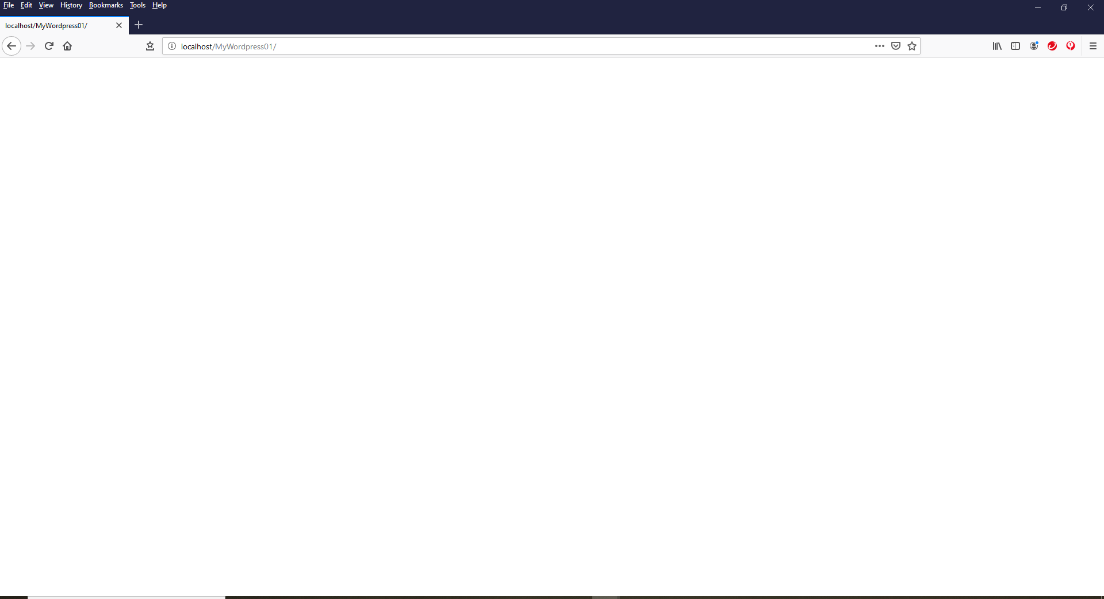

This time in the developer tools there is something that should give you a clue to what this page is. You can see the commented line 5 appearing in the code

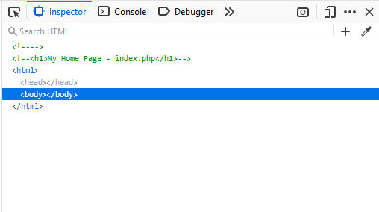

Now un-comment the line 5 html code and see what happens with the page when viewed in the browser. You should now be seeing the h1 tag with the “My Home Page – index.php” as the heading.

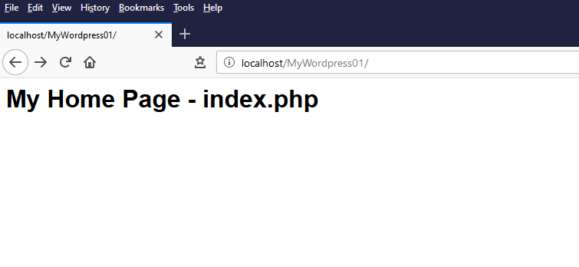

The next step is to add the head of the html as there is no code for this when you look at the developer tools in the browser. Therefore, there is a “header.php” file in the folder. Open this up in your editor and have a look at what is in this file. It should look like the following screenshot.

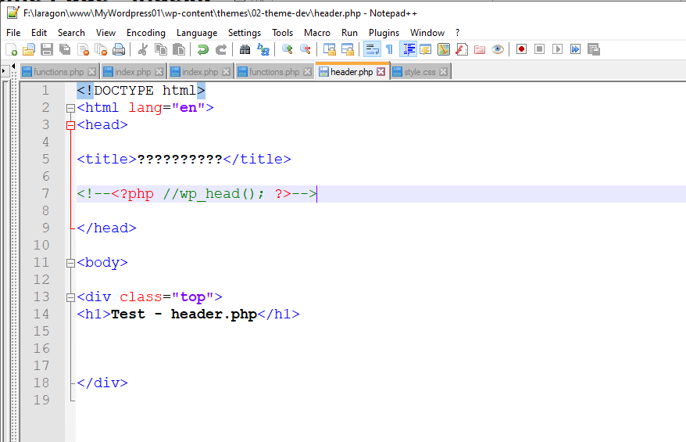

Now, two things are going to happen when we add this file. The index page is going to have the head attached which will also contain the default head information for WordPress. It includes a lot of features that could be turned off later.

At this point, you will need to go back to the “index.php” file and un-comment the php line so that the head will show up with the index page.

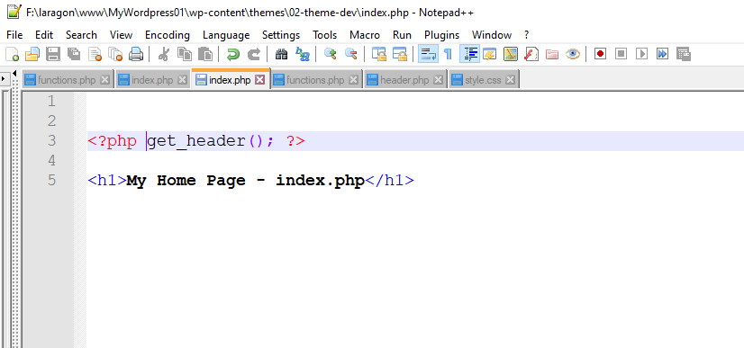

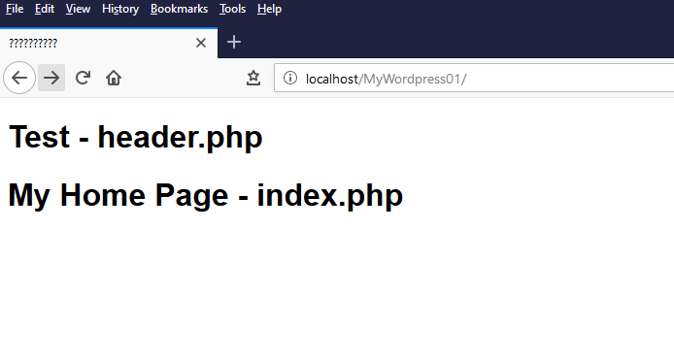

Notice also that you now have a title in the browser tab as well.

Look at the code in the developer tools to see what is going on now.

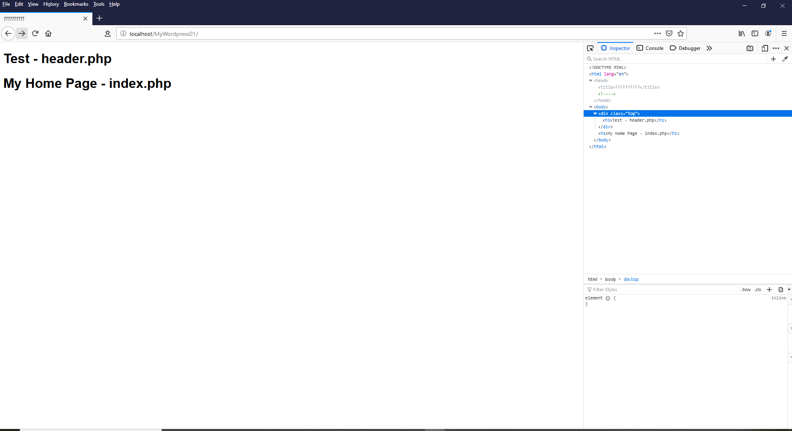

You can see that the “index.php” page and the “header.php” files are now working together. There is still a little way to go before you can add the style in this.

If you now go back to the “header.php” file and un-comment the php script. This file is to include the head information for WordPress. When you refresh the browser window and have a look at the developer tools again, you will see a lot more information. This is the default WordPress head information that has included “Features” as they say.

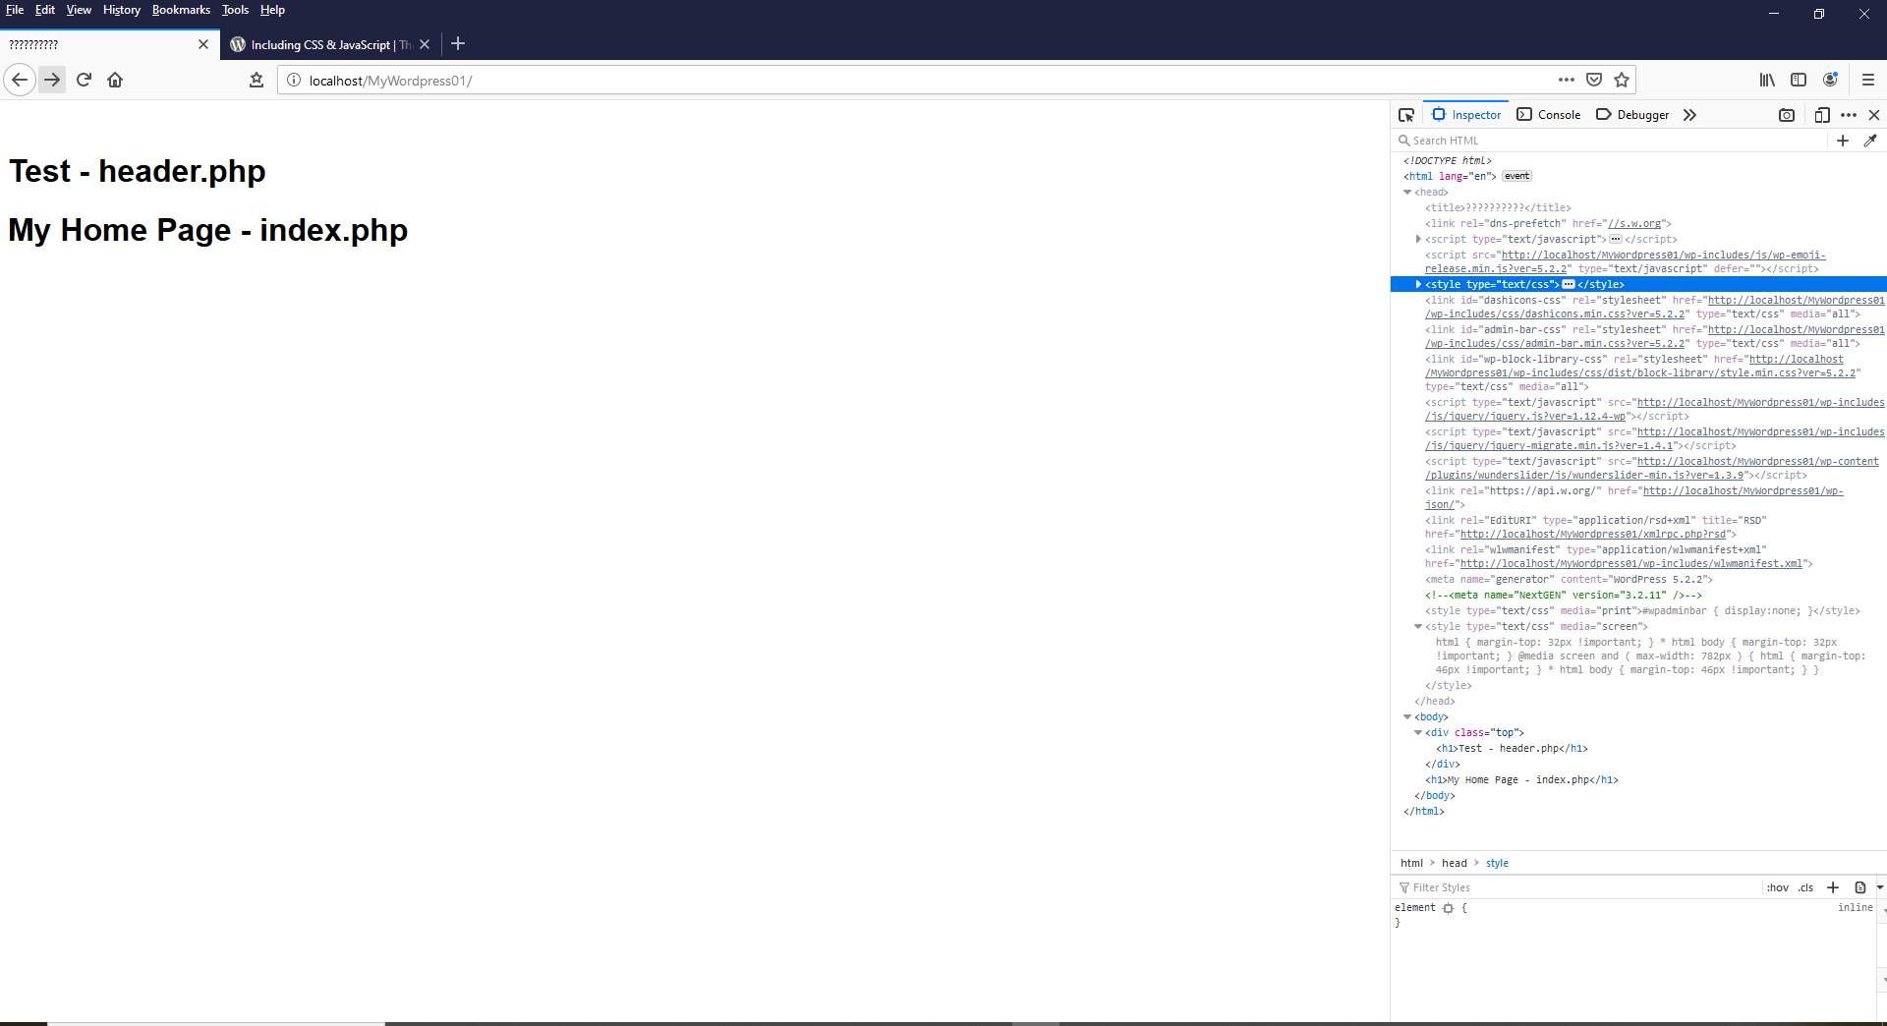

At this point we still do not have our code pointing to the CSS folder with the style sheet in. Have a look at the style sheet to see that I have given one style for when the style sheet gets activated.

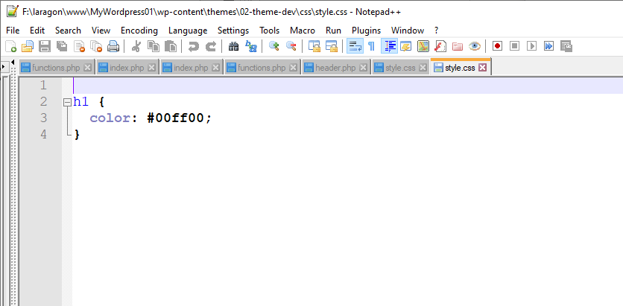

It’s not much but will shortly prove a valuable start when it works.

To get the style sheet working in WordPress without the default in the main directory, you need to open the “functions.php” file. When opened in your editor, you should see the commented code of the function for our style sheet.

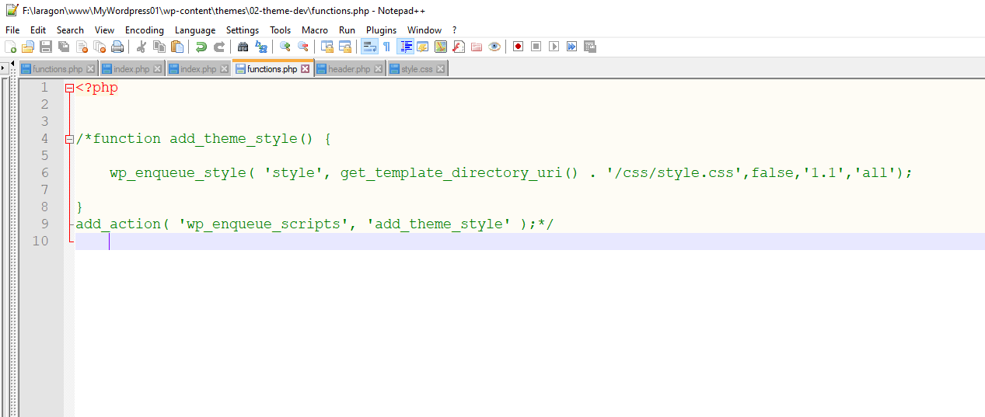

WordPress recommends the “enqueue” to add the style sheet. See the WordPress developer handbook for more detail on how to add style and JavaScript.

<https://developer.wordpress.org/themes/basics/including-css-javascript/>

Un-comment the code, save and refresh your browser.

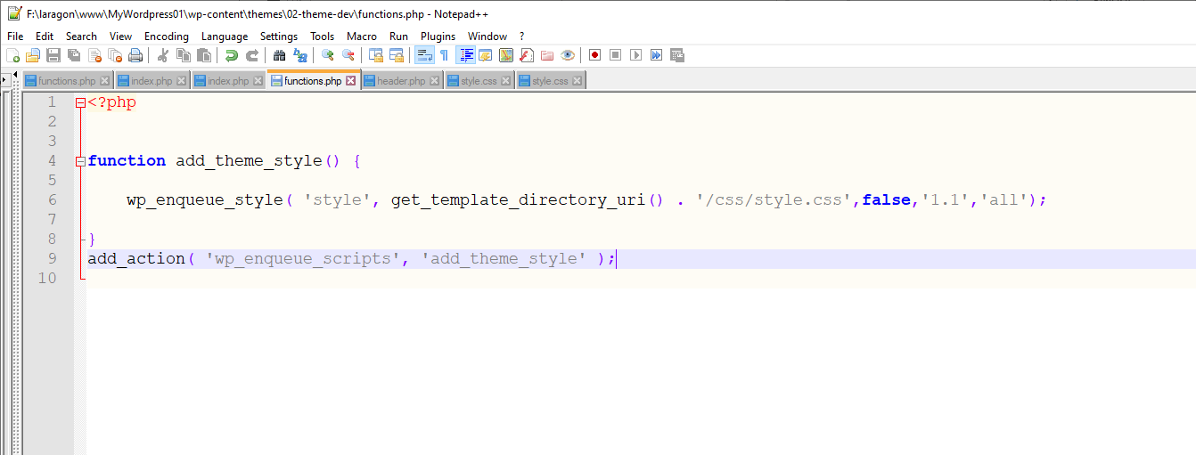

You should now see the heading change colour.

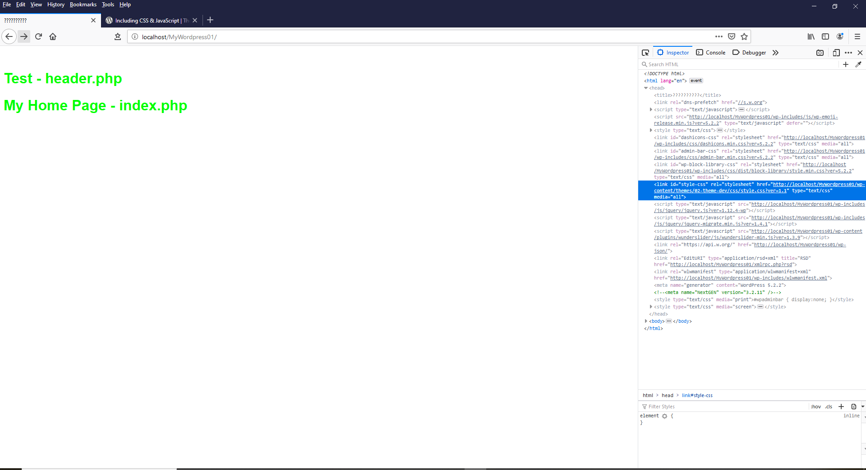

Your style sheet is now working, and you can see in the developer tools that the stylesheet line is now added.

We can start to work on the next steps. See 03-Theme Development